**“A Huge Microworld” (English, grades 10-11)**

**Teacher’s Worksheet**

**Episode 1. The Start of the Exhibition**

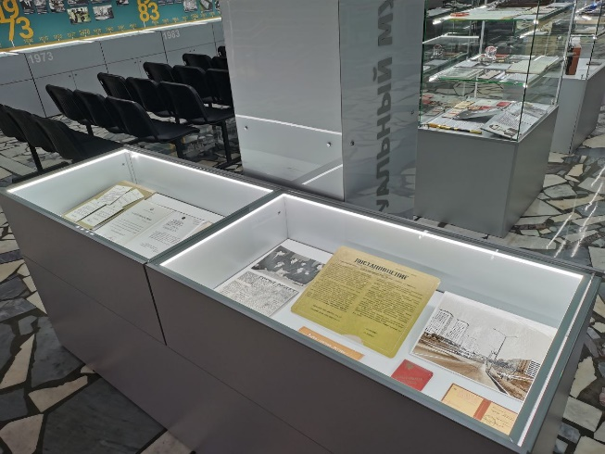

***Task 1A.*** *We are now at the start of the exhibition. It opens with a display case containing historic documents connected with Zelenograd and the museum.*

*Study Decree 248, March, 3, 1958 and say if the information below is true, false or not stated in it.*

1. The new city was to decrease the density (=плотность) of population in Moscow. T
2. The construction of the city was to start in 1958. F, 1959
3. The first buildings in Zelenograd were to be up to ten storeys high. F, four
4. The flats were to be communal and become homes for several families. F, one flat was to be occupied by one family
5. Zelenograd was to have the necessary cultural, social and industrial infrastructure. T
6. The city was to be connected with Moscow by several bus routes. N/s
7. Zelenograd was to become part of Moscow from the start. T

***Task 1B.*** *All the sentences in Task 1A contain one and the same grammar structure. Can you see it?* – to be + to Vinf

*What do we call the verbs that go before other verbs and describe our abilities, duties and wishes?* – modal verbs

*Which ones do you know?* – Can, may, must, should, need, ought to, have to, etc.

*What do you think the verb “to be” as a modal one means? –* a duty according to an agreement or a plan

*Make three more sentences about Zelenograd using the materials of the display case and the modal verb “to be”.*

____________________________________________________________________________________________________________________________________________________________________________________________________________

***Task 1C.*** *Return to Task 1A and find the English for «плотность». Many words that describe geometrical and physical values (=геометрические и физические величины) came into English from Latin. That is why the Latin letter that stands for the value is also the first letter of the English term (=термин).*

*Use the letters and words from the box below to complete the table.*

t L P r V f m P a

mass surface area energy temperature velocity pressure length diameter time acceleration volume power

диаметр площадь температура энергия скорость сила давление периметр радиус

|  |  |  |
| --- | --- | --- |
| **Latin letter** | **English term** | **Russian term** |
| d | density | плотность |
| L | length | длина |
| S | surface area | площадь |
| P | perimeter | периметр |
| V | volume | объем |
| r | radius | радиус |
| D | diameter | диаметр |
| m | mass | масса |
| t | time | время |
| v | velocity | скорость |
| a | acceleration | ускорение |
| F | force | сила |
| E | energy | энергия |
| P | power | мощность |
| p | pressure | давление |
| T | temperature | температура |

**Episode 2. The Timeline**

***Task 2.*** *The Russian microelectronics industry has a rich history. Study the timeline along one of the walls and fill in the gaps in the text with dates.*

1. Anders Jonas Ångström [ˈæŋstrəm] (1814-1874) was a prominent Swedish physicist known for his studies of astrophysics, magnetism, thermal engineering and the aurora borealis (=северное сияние). Ångström founded the science of spectroscopy – a science that studies electromagnetic spectra and measures the wavelengths of light. The angstrom is a unit of length equal to 10−10 m. Thus, the name perfectly suits a plant that makes microscopic equipment. The experimental plant *Angstrom* appeared in 1963.
2. Among the plant’s first products were *Micro*, the smallest radio receiver in the world created in 1964 and popular in the USA, Great Britain and France, and *Electronika 001*, a portable cardiographer designed in 1967 and used in a transatlantic expedition.
3. The first Soviet spaceship board computer *Argon 11C* was developed in 1969. Under its command for the first time in history a Soviet spaceship made a flight round the Moon and safely returned to the Earth.
4. A calculator is one of the most basic tools we use. The first microcalculator in our country, *Electronika BZ-04*, was designed in 1973 and followed shortly by the first Soviet microprocessor in 1974.
5. The 80s made an impact on the daily life technology and entertainment industry. In 1983 the first Soviet PC, *Electronika BK-0010*, was created. The era of private use began.We remember the year 1984 for the legendary *Nu, pogodi!* videogame. It had several spinoffs and developed the player’s planning skills as well as reaction.
6. The 90s began with advances in medical technology. In 1991 *Angstrom* launched the production of implantable cardiostimulants of various complexities. By 1994 the general production of microelectronic elements for watches, games and other devices in certain market areas had reached 90 % of the global market.
7. Plastic cards and door phones were revolutionary in the 2000s and 2010s. In 2006 the plant started making microelectronic units for plastic cards still used today. Home security became tighter in 2019 when contact door phone control keys appeared. And the prospects seem more and more intriguing.

**Episode 3. Input Devices**

***Task 3A.*** *Pay attention to the keyboards you see in the museum. What layouts (=раскладки) have you noticed? Why are they different? Read the passage below and put the words in brackets into the necessary form.*

The Epic Evolution of Keyboards: From QWERTY to JCU and Beyond

Keyboards are everywhere – on your laptop, phone, even your smart fridge. But have you ever wondered why the letters 1. (arrange) are arranged the way they are? The truth is 2. (exciting) more exciting than you think – it’s a story of typewriter wars, language battles, and even Soviet computing history!

The Birth of QWERTY: A Typewriter Accident?

In the 1860s, the American inventor Christopher Sholes 3. (work) worked / was working on the first practical typewriter. Early prototypes had keys arranged alphabetically, but there was a big problem: if people typed too fast, the metal arms 4. (hold) holding the letters would crash into each other and jam.

The solution? QWERTY – a layout 5. (design) designed to slow typists down by placing common letters (like “E” and “R”) farther apart. By the 1870s, Remington, a gun manufacturer (!), mass-produced 6. (typewriter) typewriters with this layout. Even though modern keyboards don’t jam, QWERTY stuck around – just like the “save” icon still being a floppy disk!

Fun fact: some claim QWERTY helped salespeople type the word “TYPEWRITER” quickly 7. (use) using just the top row. Coincidence? Maybe not!

***Task 3B.*** *Continue reading. Make the necessary words using the ones in brackets. Make all the necessary grammar changes.*

JCU Layouts: Europe’s Keyboard Rebellion

Not everyone uses QWERTY. In Germany, keyboards start with QWERTZ (swapping Y and Z because “Z” is used more, like in “zwei” for “two”). In France, it’s AZERTY – moving letters to fit accents (é, è, ç).

But the weirdest one? The UK keyboard has a tiny “Enter” key and a giant left “Shift” – blame the early British typewriters!

The Russian ЙЦУКЕН: A Soviet Computing Know-how

This layout wasn’t random – it was 1. (care) carefully designed in the Soviet era for typewriters.

Early Russian typewriters experimented with Latin letters before switching to Cyrillic. The ЙЦУКЕН layout placed the most-used Russian letters (like “О”, “А”, “И”) under the strongest fingers. 2. (Punctuate) Punctuation marks were moved to fit Russian grammar better.

Today, Russian 3. (game) gamers and 4. (code) coders sometimes switch to “phonetic” layouts, where Cyrillic letters match QWERTY sounds (А = A, Б = B). But ЙЦУКЕН is still king.

**Episode 4. Sterile Chamber**

***Task 4.*** *You have a checklist for a new employee working in a sterile [ˈsteraɪl] chamber for testing modern microchips. However, something has gone wrong and the checklist contains mistakes. Pair up with someone who has a different variant. Instruct each other, find and correct the mistakes. Check if you have corrected all the mistakes with the group and the teacher.*

|  |  |
| --- | --- |
| **Variant 1** | **Variant 2** |
| **1. Microchip Quality Control**   * Ensure the microchip is free from defects. * Check for any visible damage. * Follow the testing protocol precisely. * Record all data accurately in the logbook.   **2. Safety Rules**   * Wear protective gear if you wish. * Avoid sudden movements inside the chamber. * Some surfaces must be touched without gloves. * Report any safety concerns immediately.   **3. Essential Tools**   * Use the microscope for detailed inspection. * Handle the microchip with anti-static tweezers. * Keep the water for cleaning ready. * Dispose of waste in the designated container.   **4. Chamber Setup**   * The chamber maintains a sterile, dust-free environment. * Air filtration runs periodically. * Work only under the UV light when required. * Keep the door closed at all times.   **5. Worker’s Attire**   * Wear a full cleanroom suit, gloves, and a face mask. * Ensure no skin or hair is exposed. * Change into sterile shoes before entering. * Keep your jewelry on if it does not interfere with your actions. | **1. Microchip Quality Control**   * Ensure the microchip is free from defects. * Check for any visible damage. * Do not stick too strictly to the testing protocol. * Record all data accurately in the logbook.   **2. Safety Rules**   * Always wear protective gear. * Avoid sudden movements inside the chamber. * Do not touch surfaces without gloves. * Report any safety concerns immediately.   **3. Essential Tools**   * Use the microscope for detailed inspection. * Handle the microchip with your fingers. * Keep the cleaning chemical ready. * Dispose of waste in the designated container.   **4. Chamber Setup**   * The chamber maintains a sterile, dust-free environment. * Air filtration runs continuously. * Work only under the UV light when required. * Keep the door closed or open to your comfort.   **5. Worker’s Attire**   * Wear a full cleanroom suit, gloves, and a face mask. * Ensure no skin or hair is exposed. * Change into sterile shoes after entering. * Remove all jewelry before work. |

*9 mistakes corrected – Congrats! You are security experts!*

*7-8 mistakes corrected – Well done, you have a great security potential!*

*5-6 mistakes corrected – Welcome to the industry, novice! Do your best to learn!*

*4 and fewer – Please, stay away from the chamber… Just joking 😊*

***Task 5.*** *Do the Case Task or use its questions for a final discussion.*